RPM Build Instructions for Storm

To build the RPMs for Storm you first need to create a binary image from compiling the source. Storm source is in Java and Clojure; both compile in the JDK.

Download the source distribution from: <http://storm-project.net/downloads.html>

We picked 0.8.2 for this example.

>wget <https://dl.dropbox.com/u/133901206/storm-0.8.2.zip>

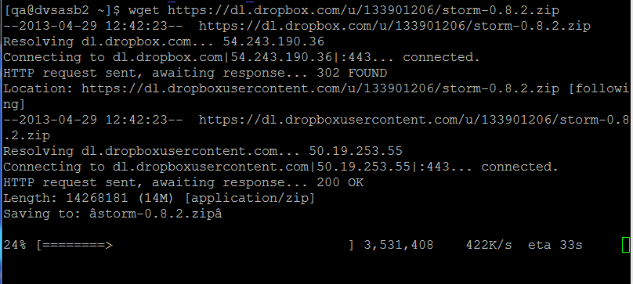

If the binary distribution doesn’t exist, you will have to extract and compile the source code. The project definitions are in project.clj.

Download leinegen-1.X from: <https://github.com/technomancy/leiningen>

Make sure to select the 1.x branch. When you click on the link leiningen displays as a text file. Save the text file as lein, chmod 755 and run it as an executable. Install rlwrap, sudo yum install rlwrap

If you are building from source you have to install jzmq and zeromq by downloading these from the github repos first. Match the version numbers download and compile.

Install zeromq-2.1.7 first. Sudo yum install gcc-c++, libuuid-devel.x86_64, make, sudo make install, sudo ldconfig.

zeromq: has additional dependencies. Install a Java jdk and link /usr/bin/javac to the installed jdk. Sudo yum install jdk-1.6.0-openjdk-devel-x86_64

jzmq-2.1.0: <https://github.com/zeromq/jzmq/tree/v2.1.0>, has a additional dependencies on a Centos system, run ldconfig to add /usr/lib64 to the g++ linker path

<https://github.com/zeromq/jzmq/archive/v2.1.0.zip>, mv v.2.1.0 jzmq-2.1.0.zip, sudo yum install libtool

To download leinigen:

$ wget <https://github.com/technomancy/leiningen/archive/1.x.zip>

$ mv 1.x leiningen-1.x.zip

$ unzip leiningen-1.x.zip

$ cd leiningen-1.x/bin

$ sudo cp lein /usr/bin/lein

Run :

>lein deps; if there are no error messages, build the storm-0.8.2.jar

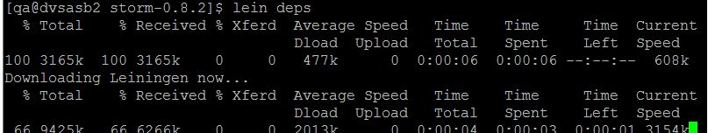

>lein jar to build the storm jar. You should see a classes, and src directory which don’t exist in the binary distribution. Delete these directories after a successful build. The rest of these files and directories are packaged in the rpm and copied to directory /opt/storm

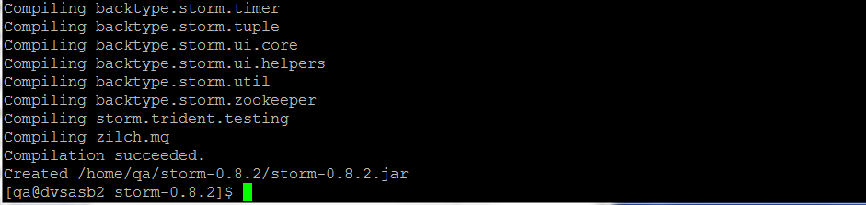



Delete the source, test and classes directories and the project.clj to create the binary distribution. The distribution directory should look like:

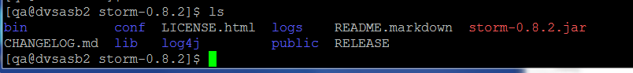

Git clone <https://github.com/acromusashi/storm-installer>. This creates a directory storm-installer which we will use to modify the existing spec files and to create the rpm package.

An RPM file is an enhanced archive. In addition to containing a compressed version of the storm binaries it contains bash programs which are called to start and stop the 3 storm components as services. These 3 scripts can be combined into 1 script to stop and start all the storm components.

To create the rpm,

>sudo yum install rpm-build

Rpmbuild creates an rpmbuild directory under your home directory if you didn’t set $buildroot in the spec file. Copy the binary tgz file into rpmbuild/SOURCES. You can change the archive type to .tar or .zip by modifying the spec file. This is the archive file you have to create from the binary distribution or compiled sources just created.

Modify the storm.spec source location:

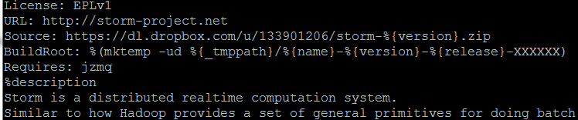

If the downloadable binary isn’t available and only the source is available, set the location to your local file directory using <file://locationofarchivebinarydistribution>

Run the rpmbuild command:

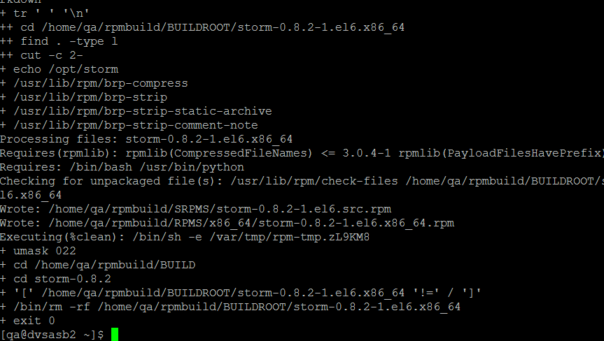

If there are no error messages, the completed build is under ~/rpmbuild/RPMS

